Phishing Alert Button Technical Handover Guide

Phishing Alert button – outlook implementation

A guide to implementing phishing alert button in your business

Contents

Code Documentation 2

Languages / Formats Used Within This Project 2

Build Process 2

Current Source 2

Running And Implementing 3

# Code Documentation

## Languages / Formats Used Within This Project

* JavaScript
* XML
* HTML
* CSS
* HandleBars
* JSON
* ENV

## Build Process

The build process for this application was set out in two separate stages,

* Client based Button (Outlook Implemented)
* Client based webpage (On which reporting will be done)

The project was all coded inside of visual studio code, a guide on how to create add-ins similar to this button can be found at

* <https://docs.microsoft.com/en-us/outlook/add-ins/quick-start?tabs=visual-studio>.

The reporting web-side of the application includes OAuth2 authentication, creating cookies, session variables and API requests. A guide to how these featured can be implemented at the following.

* <https://docs.microsoft.com/en-us/previous-versions/office/office-365-api/api/version-2.0/mail-rest-operations>
* <https://docs.microsoft.com/en-us/outlook/rest/node-tutorial#implementing-oauth2>

## Current Source

The current code source can be found at the repository below

* <https://github.com/PhishingEmails/Phishing-Email-Button.git>

## Running And Implementing

The program is run via node.js and can be ran through the command prompt at this developmental stage.

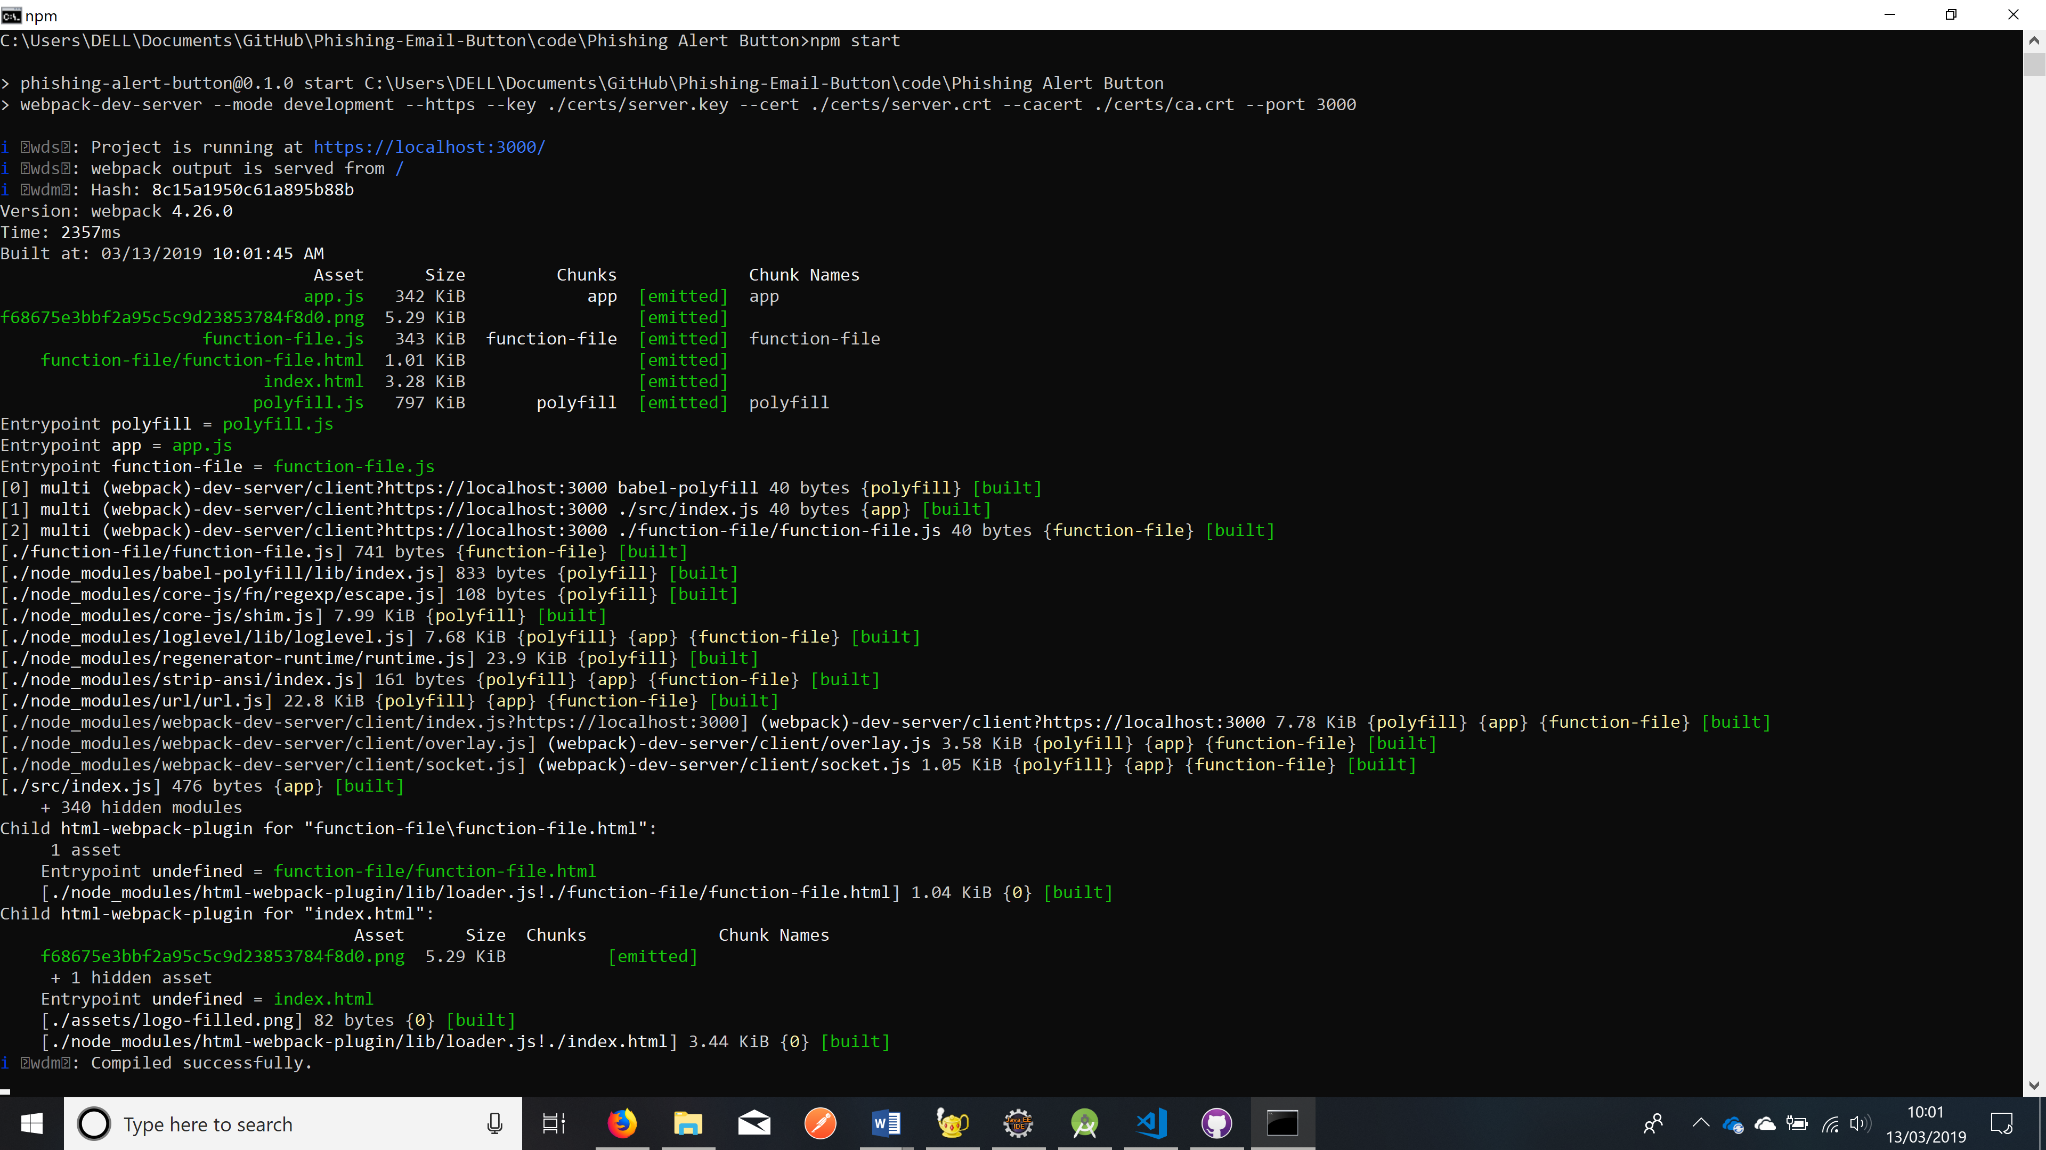

Figure - Phishing Alert Button Outlook Add-In Server - Running On Localhost 3000

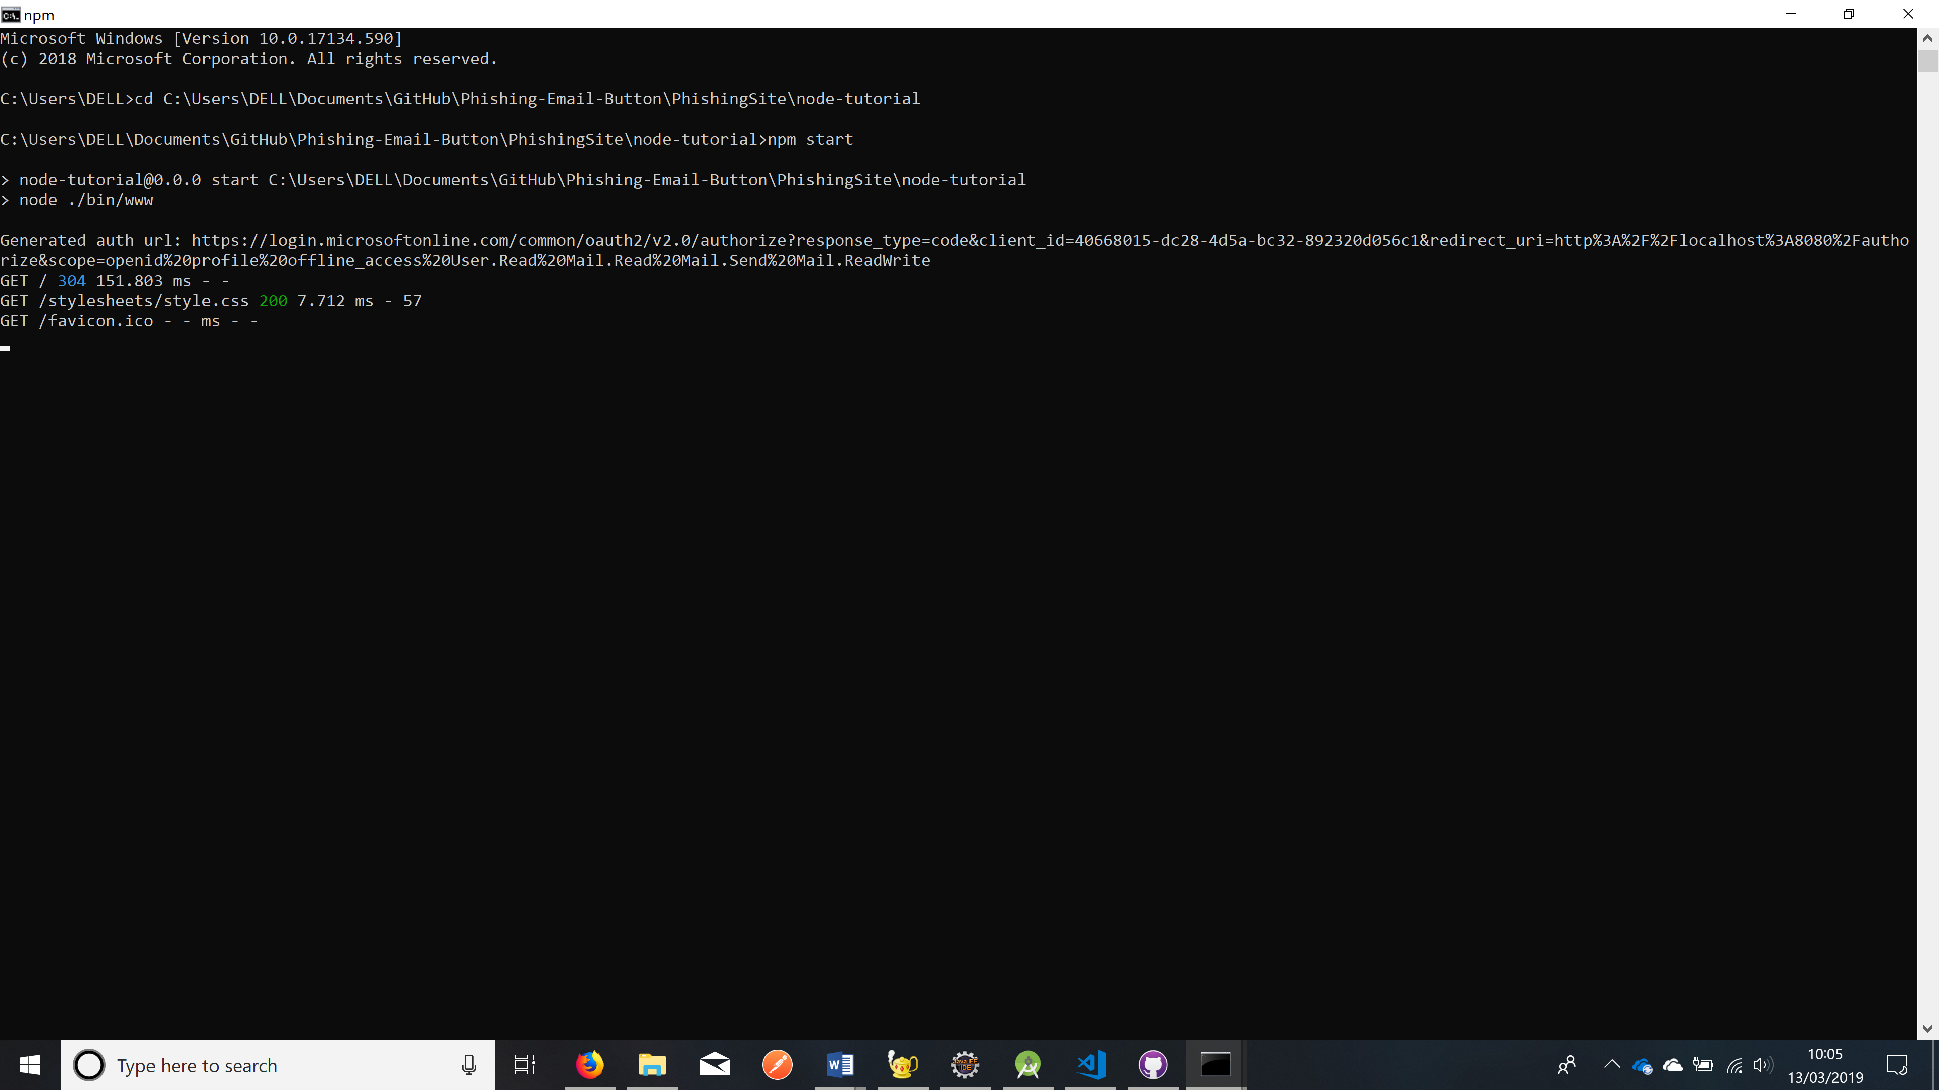

Figure - Web Side - Running On Localhost 8080

Once both servers are running, You can add your add-in to the client email as follows:

* <https://docs.microsoft.com/en-us/outlook/add-ins/sideload-outlook-add-ins-for-testing>

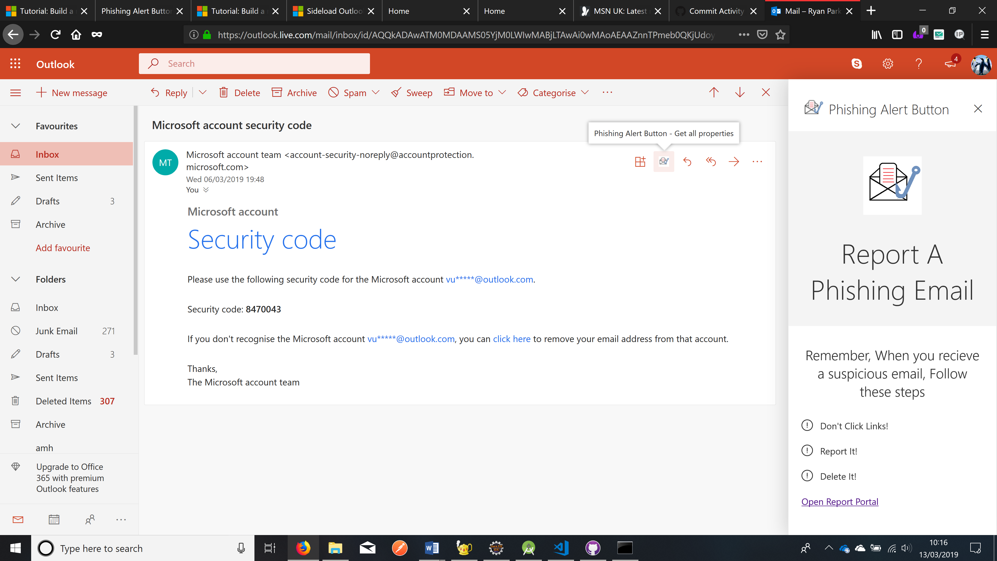

Figure - Phishing Button On Outlook - Client Side

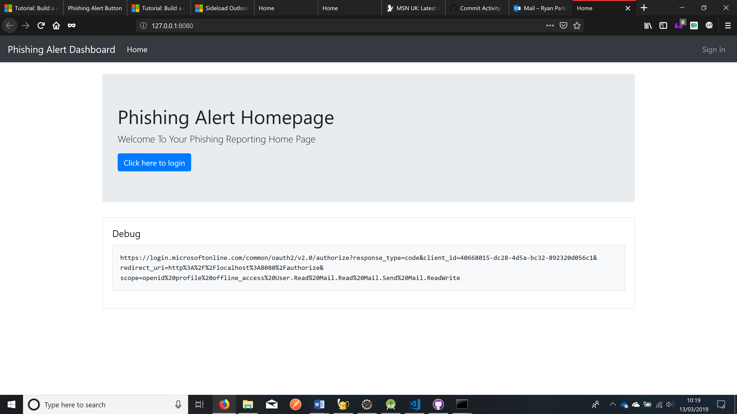

Figure - Web Side Running - Client Side

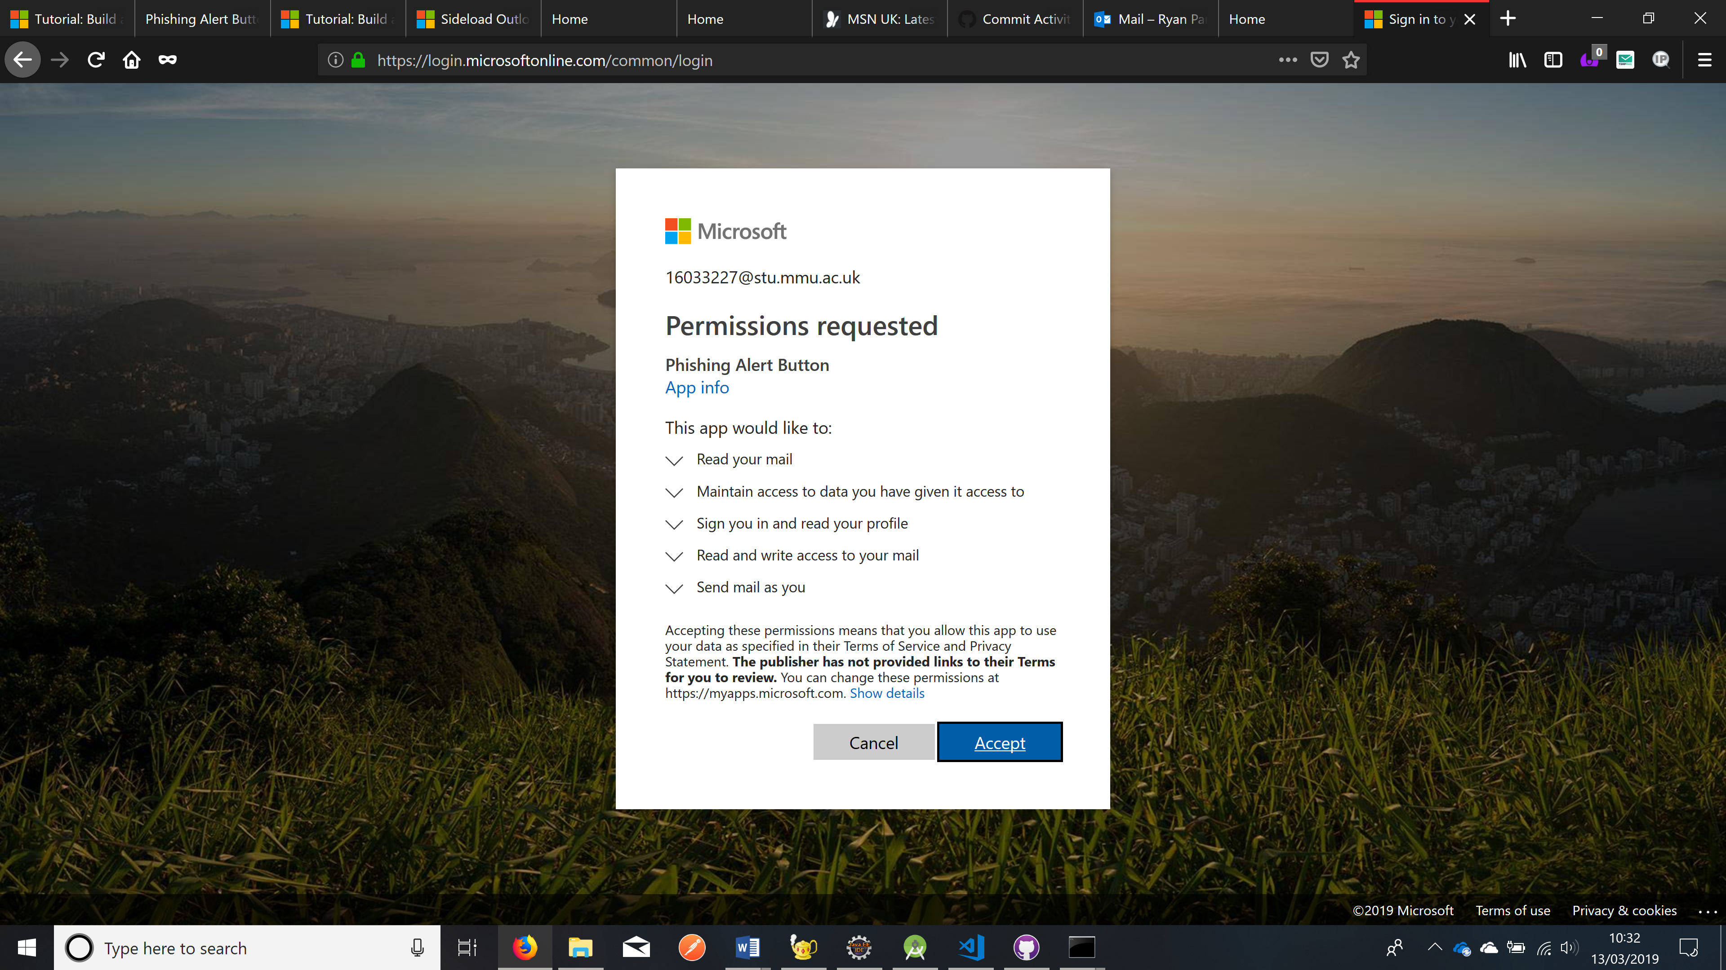

Figure - Permissions will be requested the first time a user tries to log-on to the site

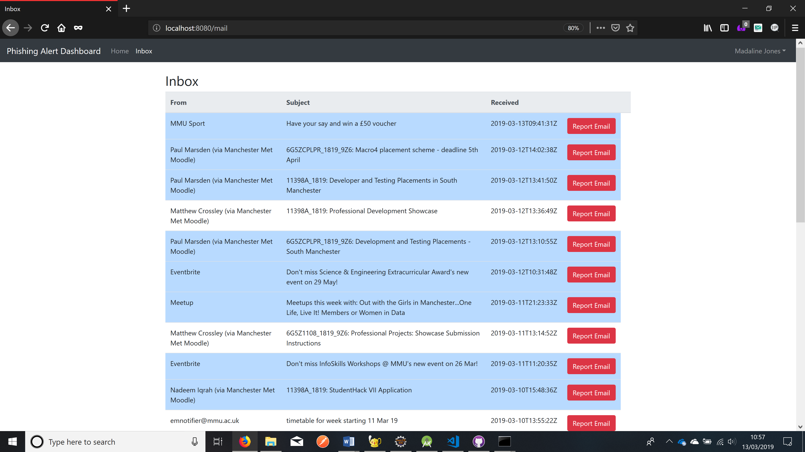

Figure - Mail Screen - User Can Report Emails From Here